
A 10
Sreenidhi Institute of Science & Technology
(An Autonomous Institution)
Code No: 101MA01/111MA01

B. TECH. I – Year I – Semester Examinations, February, 2013 (Supplementary)
ENGINEERING MATHEMATICS – I ( Common to all branches except BT )

Time: 3 Hours Max. Marks : 70

Note : No additional answer sheets will be provided.

Part-A (Objective Type)
Max.Marks:20

Answer all QUESTIONS.

1. Test the convergence of the series 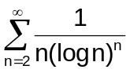.
2. Test the convergence of the series
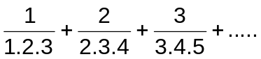
3. Show that the function
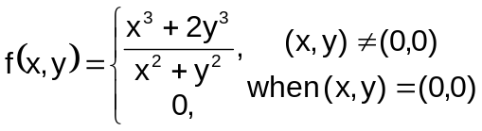
is continuous at (0,0)
4. If f(x,y)=x cosy + e^{x} siny; x=t²+1; y=t³+t, find 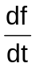 at t=0.
5. Show that the set of vectors x₁=(1,1,0); x₂=(0,1,1) and x₃=(1,0,1) are linearly independent.
6. Prove that the Eigenvalues of Diagonal matrix are diagonal elements.
7. Find the length of the arc of the curve y=x(2-x) as x varies from 0 to 2.
8. Find the Eigenvalues of the matrix
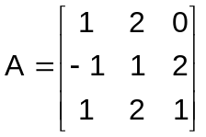.
9. Show that 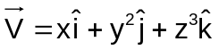 is irrotational.
10. Evaluate 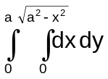.
Part – B
Max. Marks: 50
ANSWER ANY FIVE QUESTIONS. EACH QUESTION CARRIES 10 MARKS.

1. a) Test for convergence of the series [ 5 ]
1+3x+5x²+7x³+....

b) Test the convergence of the series [ 5 ]
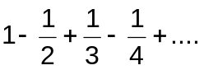
2. a) Investigate for what values of λ and μ the system of equations. [ 5 ]
2x+3y+5z=9; 7x+3y-2z=8; 2x+3y+λz=μ
have i) no solution ii) a unique solution and iii) an infinite number of solutions
b) Find the rank of the matrix [ 5 ]
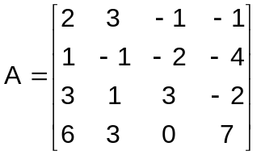
after reducing the matrix to the normal form.
3. a) Find the Eigen values and Eigen vectors of the matrix. [ 5 ]
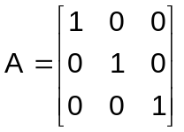.
b) Verify Cayley - Hamilton theorem for the matrix. [ 5 ]

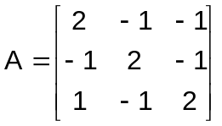
and hence find A⁻¹.
4. a) If x=r cos θ cos φ, y=r cos θ sin φ and z=r cos θ find 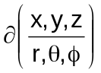. [ 5 ]
b) Find the maximum and minimum values of the function. [ 5 ]
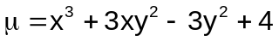
5. a) Change the order of integration to evaluate the integral. [ 5 ]
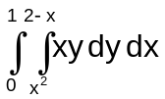
b) Evaluate 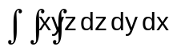over the volume enclosed by three co - ordinate plane and the plane x+y+z=1. [ 5 ]
6. a) Show that the vector field 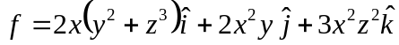 is conservative and find its scalar potential. [ 5 ]

b) Evaluate 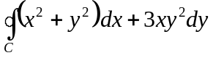 by using Green’s theorem, where C is the circle x²+y²=4 traversed in the positive direction. [ 5 ]
7. a) Verify Lagrange's mean value theorem for f(x)=Sinx in [0,π]. [ 5 ]

b) If u=sin⁻¹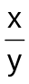⁺ tan⁻¹, prove that 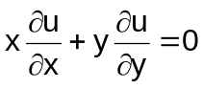 [ 5 ]
8. a) If 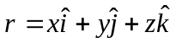, find grad (r^{n}). [ 5 ]
b) Evaluate 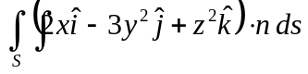over the surface bounded by x²+y²=1 and z=0, z=2 by using Gauss divergence theorem. [ 5 ]
- 00 - 00 -

